

(ANISO9001-2008CERTIFIEDINSTITUTION)

(ApprovedbyAICTE,NewDelhi&AffiliatedtoAnnaUniversity)

No.60,Avadi–VelTechRoad,Chennai-600062.

21AI37P-JAVAPROGRAMMINGLABORATORY


NAME :

REGISTERNO :

ROLL NO :

BRANCH : B.Tech-ArtificialIntelligenceandDataScience YEAR : II
SEMESTER : III

(ANISO9001-2008CERTIFIEDINSTITUTION)
(ApprovedbyAICTE,NewDelhi& AffiliatedtoAnnaUniversity)
No.60,Avadi–Vel Tech Road,Chennai-600062.

BONAFIDECERTIFICATE

Name…………………….……………………………..………….….………………….….……………… Year:………..Semester:…………..Branch:….B.TECHArtificialIntelligenceandDataScience……..
UniversityRegisterNo: CollegeRollNo:
Certifiedthatthisisthebonafiderecordofworkdonebytheabovestudentin the
21AI37P-JAVAPROGRAMMINGLABORATORYduringtheacademicyear2025-2026.

SignatureofLabIncharge SignatureofHeadoftheDepartment

SubmittedfortheUniversityPracticalExaminationheldon. atVELTECHHIGH TECH
Dr.RANGARAJANDr.SAKUNTHALAENGINEERINGCOLLEGE,No.60,AVADI –VELTECH ROAD, AVADI, CHENNAI-600062.
SignatureofExaminers

InternalExaminer:…………………… ExternalExaminer:……………………
Date:…………….……..

DepartmentofArtificialIntelligenceandDatascience

VISIONOFTHEDEPARTMENT

TobeacentreofexcellenceinthefieldofArtificialIntelligenceandDataScience.

MISSIONOFTHEDEPARTMENT
- ToprovideconducivelearningenvironmentforqualityeducationinthefieldofArtificial Intelligence and Data Science.
- Topursueindustryinstituteinteractionandpromotecollaborativeresearchactivities.
- Toempowerthestudentswithethicalvaluesandsocialresponsibilitiesintheirprofession

PROGRAMMEOUTCOMES(POS)
- PO1:Engineering knowledge:Apply the knowledge of mathematics, science, engineering fundamentals,and anengineering specialization to the solutionofcomplex engineering problems.
- PO2:Problemanalysis:Identify,formulate,reviewresearchliterature,andanalyzecomplex engineeringproblemsreachingsubstantiatedconclusionsusingfirstprinciplesofmathematics, natural sciences, and engineering sciences.
- PO3:Design/developmentofsolutions:Designsolutionsforcomplexengineeringproblemsand designsystem componentsorprocesses that meet the specified needs with appropriate consideration
forthepublichealthandsafety,andthecultural,societal,andenvironmentalconsiderations
- PO4: Conduct investigations of complex problems: Use research-based knowledge and research methods including design of experiments, analysis and interpretation of data, and synthesis of the information to provide valid conclusions.
- PO5: Modern tool usage: Create, select, and apply appropriate techniques, resources, and modern engineering and IT tools including prediction and modelling to complex engineering activities with an understanding of the limitations.
- PO6: The engineer and society: Apply reasoning informed by the contextual knowledge to assesssocietal, health, safety, legal and cultural issues and the consequent responsibilities relevant to theprofessional engineering practice
- PO7: Environment and sustainability: Understand the impact of the professional engineering solutions in societal and environmental contexts, and demonstrate the knowledge of, and need for sustainable development.
- PO8: Ethics: Apply ethical principles and commit to professional ethics and responsibilities and norms of the engineering practice.

- PO9: Individual and team work: Function effectively as an individual, and as a member or leader in diverse teams, and in multidisciplinary settings.
- PO10: Communication:Communicate effectively on complex engineering activities with the engineering community and with society at large, such as, being able to comprehend and write effective reports and design documentation, make effective presentations, and give and receive clear instructions.
- PO11: Project management and finance:Demonstrate knowledge and understanding of the engineering and management principles and applythese to one’s own work, as a member and leader in a team, to manage projects and in multidisciplinary environments.
- PO12: Life-long learning:Recognize the need for, and have the preparation and ability to engage in independent and life-long learning inthe broadest context oftechnological change.

PROGRAMMEEDUCATIONALOBJECTIVES(PEOS)

  - Exhibitprofessionalskillstodesign,developandtestsoftwaresystemsforrealtimeneeds.
  - ExcelassoftwareProfessionalorEntrepreneur.
  - Demonstrateasenseofsocietalandethicalresponsibilitiesintheirprofession.
  - ​

PROGRAMMESPECIFICOUTCOMES(PSOS)
AfterthesuccessfulcompletionofB.TechProgrammein ArtificialIntelligenceandDataScience, Graduates will be able to,
  - Applytheacquired knowledgeandmoderntechniques inthefieldofArtificialIntelligence andData Science based systems.
  - Design andintegrateArtificial IntelligenceandDataSciencebasedsolutions tomeetthe desired needs of society.

COURSEDETAILS
COURSE OBJECTIVES:
Thestudentshouldableto:
- Tobuildsoftwaredevelopmentskillsusingjavaprogramming forreal-worldapplications.
- Tounderstandandapplytheconceptsofclasses,packages, interfaces,arraylist,exception handling and file processing.
- Todevelopapplicationsusinggenericprogrammingandeventhandling.

COURSEOUTCOMES:Attheendofthecourse, thestudentwillbeable to:
CONo |  | Course  Outcomes |  |  |  |  |  |  |  |  |  |  | Blooms Level
C307.1 |  | WritejavaprogramtoimplementOOPSConcepts. |  |  |  |  |  |  |  |  |  |  | K2
C307.2 |  | Constructjavaprogramtoderivetheconceptsofinheritanceand  interfaces |  |  |  |  |  |  |  |  |  |  | K3
C307.3 |  | Buildjavaapplications usingexceptionsandI/Ostreams. |  |  |  |  |  |  |  |  |  |  | K3
C307.4 |  | Constructjavaapplicationcodewiththreads  andgenerics classes. |  |  |  |  |  |  |  |  |  |  | K3
C307.5 |  | Writeinteractionjavaprogramusingswingsandevent handling |  |  |  |  |  |  |  |  |  |  | K3
CO-POMAPPING:
CO | PO1 |  | PO 2 | PO 3 | PO 4 | PO 5 | PO 6 | PO 7 | PO 8 | PO 9 | PO 10 | PO 11 | PO 12 | PSO  1 | PSO  2
C207.1 | 2 |  | 1 | - | - | - | - | - | - | - | - | - | 1 | 2 | 1
C207.2 | 3 |  | 2 | - | - | - | - | - | - | - | - | - | 1 | 2 | 1
C207.3 | 3 |  | 2 | - | - | - | - | - | - | - | - | - | 1 | 2 | 1
C207.4 | 3 |  | 2 | - | - | - | - | - | - | - | - | - | 1 | 2 | 1
C207.5 | 3 |  | 2 | 1 | - | - | - | - | - | - | - | - | 1 | 2 | 1
C207 | 3 |  | 2 | 1 | - | - | - | - | - | - | - | - | 1 | 2 | 1

SYLLABUS
No.ofCredits:2
- Develop a Java application to generate Electricity bill. Create a class with the following members: Consumer no., consumer name, previous month reading, current month reading,type of EB connection (i.e domestic or commercial). Compute the billamount using the following tariff.
IfthetypeoftheEBconnection isdomestic, calculatetheamounttobepaidasfollows:
  - First100units-Rs.1perunit
  - 101-200units-Rs.2.50per unit
  - 201-500units-Rs.4perunit
  - Greaterthan501units-Rs.6per unit
IfthetypeoftheEBconnectioniscommercial,calculatetheamounttobepaidasfollows:
  - First100units-Rs.2perunit
  - 101-200units- Rs.4.50perunit
  - 201-500units- Rs.6perunit
  - Greater than501 units- Rs.7per unit
- Develop a java application to implement currency converter (Dollar to INR, EURO to INR, Yen to INR and vice versa), distance converter (meter to KM, miles to KM and vice versa) , time converter (hours to minutes, seconds and vice versa) using packages.
- DevelopajavaapplicationwithEmployeeclasswithEmp_name,Emp_id,Address,Mail_id,Mobile no as members. Inheritthe classes, Programmer, Assistant Professor, Associate Professor and Professor from employee class. Add Basic Pay (BP) as the member of all the inherited classeswith97%ofBPasDA,10%ofBPasHRA,12%ofBPasPF,0.1%ofBPforstaffclubfund. Generate payslips for the employees with their gross and net salary.
- DesignaJavainterfaceforADTStack.Implementthisinterfaceusingarray.Providenecessary exception handling in both the implementations.
- WriteaprogramtoperformstringoperationsusingArrayList.Writefunctionsforthefollowing
- Append-addatend
- Insert–addatparticularindex
- Search
- Listallstringstartswithgiven letter
- WriteaJavaProgramtocreateanabstractclassnamedShapethatcontainstwointegersandan emptymethodnamedprintArea(). ProvidethreeclassesnamedRectangle, Triangle andCirclesuch

that each one of the classes extends the class Shape. Each one of the classes contains only the method print Area () that prints the area ofthe given shape.
- WriteaJavaprogramtoimplementuserdefinedexception handling.
- Write a Java program that reads a file name from the user, displays information about whether the fileexists,whether thefile isreadable, orwritable, thetype offileandthelengthofthefile inbytes.
- Write a java program that implements a multi-threaded application that has three threads. Firstthread generates a random integer every 1 second and if the value is even, second thread computes the square of the numberand prints.If the value is odd, the third thread will printthe value ofcube
ofthenumber.18
- Write a java program to find the maximum value from the given type of elements using a generic function.
- Designacalculatorusingevent-drivenprogramming paradigmofJavawiththefollowingoptions.
- Decimalmanipulations
- Scientificmanipulations
- DevelopaminiprojectforanyapplicationusingJavaconcepts.
Total:60Periods

LEARNINGRESOURCES:
TEXTBOOKS:
- HerbertSchildt,―JavaThecompletereference‖,8thEdition,McGrawHillEducation,2017.
- CayS.Horstmann,Garycornell,―CoreJavaVolume–IFundamentals‖, 9thEdition,PrenticeHall, 2017.
- E.Balagurusamy,ProgrammingwithJava,TataMcGill.,FifthEdition,2017

REFERENCES:
- PaulDeitel,HarveyDeitel,―JavaSE8forprogrammers‖,7thEdition,Pearson,2019.Steven
Holzner,―Java2Blackbook‖,Dreamtechpress,2014.
- TimothyBudd,―UnderstandingObject-orientedprogrammingwithJava‖,Updated
- Edition,PearsonEducation,2000.

INDEX

S.No | ListofPrograms | PageNo. | Marks | Signature
1. | ElectricityBillingSystemusingJava
2. | Multi-PurposeUnitConverterUsing Java Packages
3. | EmployeePaySlipGenerationUsing Inheritance
4. | ImplementationofAbstractData Type Stack Using Interface and  ArrayinJava
5. | StringManipulationUsingArrayList  inJava
6. | AreaComputationofGeometric  ShapesUsingAbstractClasses in  Java
7. | UserDefinedExceptionHandling.
8. | FilePropertyInspector UsingJava  I/O
9. | ConcurrentProcessingofRandom NumbersUsingMultithreading in Java
10. | FindingMaximumValueUsing  GenericMethodsinJava
11. | Event-DrivenCalculatorinJava for  DecimalandScientificComputations
12. | CapstoneProjects

Ex.NO:1 ElectricityBillingSystemusingJava

AIM:
To design and implementa Java application that automates the generation of electricity bills based onconsumer usage data.

ALGORITHM:

PROGRAM:
importjava.util.Scanner; class ElectricityBill {
privateintconsumerNo;
privateStringconsumerName; private int prevReading; private int currReading;
privateStringconnectionType;//"domestic"or"commercial"
publicElectricityBill(intconsumerNo,StringconsumerName,intprevReading,intcurrReading, String connectionType) {
this.consumerNo = consumerNo; this.consumerName=consumerName; this.prevReading = prevReading; this.currReading = currReading;
this.connectionType=connectionType.toLowerCase();//normalizecase
}
public int getUnitsConsumed() { returncurrReading -prevReading;
}
publicdoublecalculateBill(){
intunits=getUnitsConsumed(); double amount = 0;
if (connectionType.equals("domestic")){
if(units<=100){
amount=units* 1;
}elseif(units<=200){
amount=100*1+(units -100)*2.5;
}elseif(units<=500){
amount=100*1 +100 *2.5+(units-200)* 4;
}else{
amount=100 *1 +100 *2.5+300* 4+(units-500)*6;
}
}elseif(connectionType.equals("commercial")){ if (units <= 100) {
amount=units* 2;
}else if(units<=200){
amount=100*2+(units -100)*4.5;
}elseif(units<=500){
amount=100*2 +100 *4.5+(units-200)* 6;
}else{
amount=100 *2 +100 *4.5+300* 6+(units-500)*7;
}
}else{
System.out.println("Invalidconnectiontype!");
}
returnamount;
}
public void displayBill() { System.out.println("\n--- ElectricityBill---");

System.out.println("Consumer No: " + consumerNo); System.out.println("Consumer Name: " + consumerName); System.out.println("Connection Type: " + connectionType); System.out.println("Previous Reading: " + prevReading); System.out.println("Current Reading: " + currReading); System.out.println("Units Consumed: "+getUnitsConsumed()); System.out.printf("TotalAmount:Rs.%.2f\n",calculateBill());
}
}
publicclassEBMain{
public static void main(String[] args) { Scannersc=newScanner(System.in);

System.out.print("Enter ConsumerNumber:"); int consumerNo = sc.nextInt();
sc.nextLine(); // consume newline System.out.print("EnterConsumerName: "); String name = sc.nextLine();
System.out.print("Enter Previous MonthReading: "); int prev = sc.nextInt();
System.out.print("Enter Current MonthReading: "); int curr = sc.nextInt();
sc.nextLine();//consumenewline
System.out.print("Enter ConnectionType (domestic/commercial): "); String type = sc.nextLine();
//CreatetheElectricityBillobject
ElectricityBillbill=newElectricityBill(consumerNo,name,prev,curr,type); bill.displayBill();
sc.close();
}
}

OUTPUT:
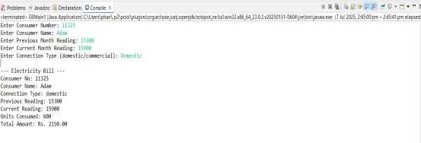

Ex.NO:2 Multi-PurposeUnitConverterUsingJavaPackages

AIM:

TodevelopaJavaapplicationthatimplementsamodularunitconverterusingJavapackages.The application should support:
- CurrencyConversion:BetweenDollar,Euro,Yen,andIndianRupees(INR)
- DistanceConversion:Betweenmeters,kilometers,andmiles
- TimeConversion:Betweenhours,minutes,andseconds

ALGORITHM:

PROGRAM:
CurrencyConverter.java
packageconverterapp;
publicclassCurrencyConverter{
publicstaticdoubledollarToInr(doubledollar){ return dollar * 83.0;
}

publicstaticdoubleeuroToInr(doubleeuro){ return euro * 90.0;
}

publicstaticdoubleyenToInr(doubleyen){ return yen * 0.56;
}

publicstaticdoubleinrToDollar(doubleinr){
returninr/83.0;
}

publicstaticdoubleinrToEuro(doubleinr){ return inr / 90.0;
}

publicstaticdoubleinrToYen(doubleinr){ return inr / 0.56;
}
}
DistanceConverter.java
packageconverterapp;
publicclassDistanceConverter{
publicstaticdoublemeterToKm(doublemeter){ return meter / 1000.0;
}

publicstaticdoublemilesToKm(doublemiles){ return miles * 1.60934;
}

publicstaticdoublekmToMeter(doublekm){ return km * 1000.0;
}

publicstaticdoublekmToMiles(doublekm){ return km / 1.60934;
}

}
TimeConverter.java
packageconverterapp;
publicclassTimeConverter {
publicstaticinthoursToMinutes(inthours){ return hours * 60;
}
publicstaticintminutesToHours(intminutes){ return minutes / 60;
}
publicstaticinthoursToSeconds(inthours){
returnhours*3600;
}
publicstaticintsecondsToHours(intseconds){ return seconds / 3600;
}
publicstaticintminutesToSeconds(intminutes){ return minutes * 60;
}
publicstaticintsecondsToMinutes(intseconds){ return seconds / 60;
}
}
Main.java
importconverterapp.CurrencyConverter; import converterapp.DistanceConverter; import converterapp.TimeConverter;
importjava.util.Scanner; public class Main {
publicstaticvoidmain(String[]args){
Scannersc=newScanner(System.in);

System.out.println("==== Converter Application===="); System.out.println("1. Currency Converter"); System.out.println("2. Distance Converter"); System.out.println("3. Time Converter"); System.out.print("Enter your choice: ");
intchoice=sc.nextInt();

switch(choice){ case 1:
System.out.println("1. DollartoINR"); System.out.println("2. Euro to INR"); System.out.println("3. Yen to INR"); System.out.println("4. INRtoDollar");

System.out.println("5. INRtoEuro"); System.out.println("6. INRtoYen"); System.out.print("Choose option: "); int c = sc.nextInt(); System.out.print("Enter amount: "); double amount = sc.nextDouble();
switch(c){
case 1: System.out.println("INR: " + CurrencyConverter.dollarToInr(amount)); break; case 2: System.out.println("INR: "+CurrencyConverter.euroToInr(amount)); break; case 3: System.out.println("INR: " + CurrencyConverter.yenToInr(amount));
break;
case 4: System.out.println("Dollar: " + CurrencyConverter.inrToDollar(amount)); break; case 5: System.out.println("Euro: " +CurrencyConverter.inrToEuro(amount)); break; case 6: System.out.println("Yen: " + CurrencyConverter.inrToYen(amount)); break; default: System.out.println("Invalid option");
}
break;
case2:
System.out.println("1. MetertoKM"); System.out.println("2.MilestoKM"); System.out.println("3. KMtoMeter"); System.out.println("4.KMtoMiles"); System.out.print("Choose option: "); int d = sc.nextInt(); System.out.print("Enter value: "); double dist = sc.nextDouble();
switch(d){
case 1: System.out.println("KM: " + DistanceConverter.meterToKm(dist)); break; case 2: System.out.println("KM: " + DistanceConverter.milesToKm(dist)); break; case 3: System.out.println("Meter: " + DistanceConverter.kmToMeter(dist)); break; case4:System.out.println("Miles:"+DistanceConverter.kmToMiles(dist));break; default: System.out.println("Invalid option");
}
break;
case3:
System.out.println("1. Hours to Minutes"); System.out.println("2. Minutes to Hours"); System.out.println("3. Hours to Seconds"); System.out.println("4. Seconds to Hours"); System.out.println("5. MinutestoSeconds"); System.out.println("6. Secondsto Minutes"); System.out.print("Choose option: ");
int t = sc.nextInt(); System.out.print("Entertime:"); int time = sc.nextInt();

switch(t){
case 1:System.out.println("Minutes: "+TimeConverter.hoursToMinutes(time)); case 2: System.out.println("Hours: " + TimeConverter.minutesToHours(time));
break;
case 3: System.out.println("Seconds: "+TimeConverter.hoursToSeconds(time)); break;
case4:System.out.println("Hours:"+TimeConverter.secondsToHours(time));
break;
case 5: System.out.println("Seconds: "+TimeConverter.minutesToSeconds(time)); break;
case6:System.out.println("Minutes:"+TimeConverter.secondsToMinutes(time));
break;
default:System.out.println("Invalidoption");

break;

}
break;
default:
System.out.println("Invalidcategoryselected.");
}
sc.close();
}
}

OUTPUT:
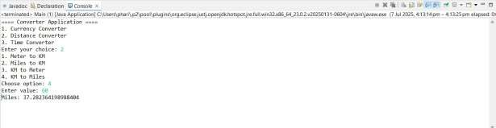

Ex.NO:3 EmployeePaySlipGenerationUsingInheritance

AIM:

Todevelop aJavaapplicationthat automates thegenerationofemployeepayslipsby:

CreatingabaseEmployeeclasswithattributeslikeemployeename,ID,address,email,and mobile number.
Inheritingspecializedclasses(Programmer,AssistantProfessor,AssociateProfessor, Professor) from the base class.
Addingsalary-related componentssuchasBasicPay(BP),andcalculatingallowancesand
deductionsincluding:
- DA(97%)
- HRA(10%)
- PF(12%)
- StaffClubFund (0.1%)
- Generatingstructuredpayslipsdisplayingbothgrossandnetsalary.

ALGORITHM:

PROGRAM:
import java.util.Scanner;

// Base class classEmployee{
StringempName,empId,address,mailId, mobileNo;
voidgetDetails(){
Scanner sc = new Scanner(System.in); System.out.print("EnterEmployeeName:"); empName = sc.nextLine(); System.out.print("Enter Employee ID: "); empId = sc.nextLine(); System.out.print("Enter Address: ");
address = sc.nextLine(); System.out.print("Enter Mail ID: "); mailId = sc.nextLine(); System.out.print("Enter MobileNo:"); mobileNo = sc.nextLine();
}
void displayDetails() { System.out.println("\nEmployeeDetails:");

System.out.println("Name System.out.println("ID System.out.println("Address System.out.println("MailID
:" +empName);
: "+empId);
:" +address);
:"+mailId);

System.out.println("MobileNo:"+mobileNo);
}
}
//Derivedclass
classProgrammerextendsEmployee{ double basicPay;
voidgetPayDetails(){
Scannersc=newScanner(System.in); System.out.print("Enter Basic Pay: "); basicPay = sc.nextDouble();
}

void generatePaySlip() {double da = 0.97 *basicPay; doublehra=0.10*basicPay; double pf= 0.12 * basicPay;
doublestaffClub=0.001*basicPay; double gross = basicPay + da + hra; doublenet=gross-(pf+staffClub);
displayDetails();

System.out.println("Designation:Programmer"); System.out.println("Basic Pay: ₹"+ basicPay); System.out.println("DA (97%) : ₹" + da); System.out.println("HRA (10%): ₹" + hra); System.out.println("PF (12%) : ₹" + pf); System.out.println("ClubFund:₹"+staffClub); System.out.println("Gross Salary: ₹" + gross); System.out.println("Net Salary: ₹" + net);
}
}

classAssistantProfessorextendsProgrammer{ @Override
void generatePaySlip() {double da = 0.97 *basicPay; doublehra=0.10*basicPay; double pf= 0.12 * basicPay;
doublestaffClub=0.001*basicPay;
double gross = basicPay + da + hra; doublenet=gross-(pf+staffClub);
displayDetails();
System.out.println("Designation :AssistantProfessor"); System.out.println("Basic Pay: ₹" + basicPay); System.out.println("DA (97%) : ₹" + da); System.out.println("HRA (10%): ₹" + hra); System.out.println("PF (12%) : ₹" + pf); System.out.println("Club Fund: ₹" + staffClub); System.out.println("Gross Salary: ₹" + gross); System.out.println("Net Salary: ₹" + net);
}
}

classAssociateProfessorextendsProgrammer{ @Override
void generatePaySlip(){
double da = 0.97 *basicPay; doublehra=0.10*basicPay; double pf= 0.12 * basicPay;
doublestaffClub=0.001*basicPay;
double gross = basicPay + da + hra; doublenet=gross-(pf+staffClub);
displayDetails();
System.out.println("Designation :AssociateProfessor"); System.out.println("Basic Pay: ₹" + basicPay); System.out.println("DA (97%) : ₹" + da); System.out.println("HRA (10%): ₹" + hra); System.out.println("PF (12%) : ₹" + pf); System.out.println("Club Fund: ₹" + staffClub);

System.out.println("Gross Salary: ₹"+gross); System.out.println("Net Salary: ₹" + net);
}
}

classProfessorextendsProgrammer{ @Override
void generatePaySlip() {double da = 0.97 *basicPay; doublehra=0.10*basicPay; double pf= 0.12 * basicPay;
doublestaffClub=0.001*basicPay; double gross = basicPay + da + hra; doublenet=gross-(pf+staffClub);

displayDetails(); System.out.println("Designation : Professor"); System.out.println("BasicPay:₹"+basicPay); System.out.println("DA (97%) : ₹" + da); System.out.println("HRA (10%): ₹" + hra); System.out.println("PF (12%) : ₹" + pf);
System.out.println("ClubFund:₹"+staffClub); System.out.println("Gross Salary: ₹" + gross); System.out.println("Net Salary: ₹" + net);
}
}
//Mainclass
publicclassEmployeeMain{
public static void main(String[] args) { Scanner sc = new Scanner(System.in); System.out.println("Select Designation:"); System.out.println("1. Programmer"); System.out.println("2.AssistantProfessor"); System.out.println("3. AssociateProfessor"); System.out.println("4. Professor"); System.out.print("Enter your choice: ");
intchoice=sc.nextInt();

switch(choice){ case 1:
Programmer p=newProgrammer();
p.getDetails(); p.getPayDetails(); p.generatePaySlip(); break;
case2:
AssistantProfessorap=newAssistantProfessor(); ap.getDetails();
ap.getPayDetails();

ap.generatePaySlip(); break;
case3:
AssociateProfessor asp=newAssociateProfessor(); asp.getDetails();
asp.getPayDetails(); asp.generatePaySlip(); break;
case4:
Professorprof=newProfessor(); prof.getDetails(); prof.getPayDetails(); prof.generatePaySlip();
break; default:
System.out.println("Invalidchoice.");
}
sc.close();
}
}

OUTPUT:
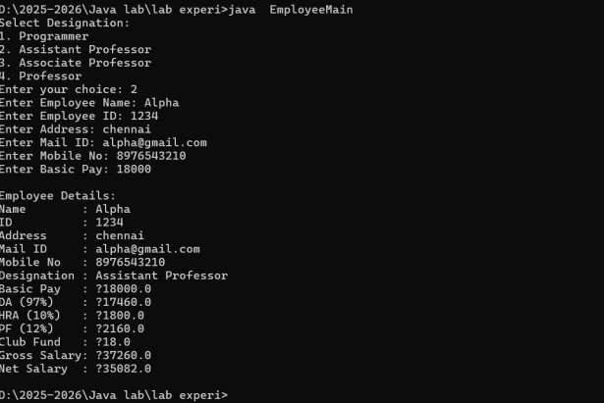

Ex. NO:4 ImplementationofStackADTUsingInterfaceandArrayinJavawithException Handling

AIM:
To design aStack Abstract Data Type (ADT) usingaJava interface and implement it usinga fixed-size array.

ALGORITHM:

PROGRAM:
import java.util.Scanner;

// Stack ADT interface interfaceStackADT<T>{
voidpush(Titem)throwsStackOverflowException; T pop() throws StackUnderflowException;
Tpeek()throwsStackUnderflowException;
booleanisEmpty();
booleanisFull();
}

//CustomexceptionforStack Overflow
class StackOverflowException extends Exception { publicStackOverflowException(String message) {
super(message);
}
}

//CustomexceptionforStack Underflow
class StackUnderflowException extends Exception { publicStackUnderflowException(String message) {
super(message);
}
}

//Stackimplementationusingarray
classArrayStack<T>implementsStackADT<T>{ private T[] stack;
private int top; privateintcapacity;

@SuppressWarnings("unchecked")

publicArrayStack(intsize){ capacity = size;
stack=(T[])newObject[capacity]; top = -1;
}

publicvoidpush(Titem)throwsStackOverflowException{ if (isFull()) {
thrownewStackOverflowException("StackOverflow:Cannotpush"+item);
}
stack[++top]=item;
}

publicTpop()throwsStackUnderflowException{ if (isEmpty()) {
thrownewStackUnderflowException("StackUnderflow:Cannotpopfromemptystack");
}
returnstack[top--];
}

publicTpeek()throwsStackUnderflowException{ if (isEmpty()) {
thrownewStackUnderflowException("StackUnderflow:Cannotpeekfromemptystack");
}
returnstack[top];
}

publicbooleanisEmpty(){ return top == -1;
}

public boolean isFull() { returntop==capacity-1;

}
}

//Mainclasstoteststackoperations public class StackDemo {
public static void main(String[] args) { Scannersc=newScanner(System.in);
ArrayStack<Integer>stack=newArrayStack<>(5);//Stackwithsize5 int choice;

do{
System.out.println("\n--- Stack Operations Menu ---"); System.out.println("1. Push");
System.out.println("2. Pop"); System.out.println("3. Peek"); System.out.println("4. Exit"); System.out.print("Enteryourchoice:"); choice = sc.nextInt();

try{
switch(choice){
case1:
System.out.print("Enter valuetopush:"); int val = sc.nextInt();
stack.push(val); System.out.println("Pushed: "+val); break;

case 2:
intpopped=stack.pop();
System.out.println("Popped: "+popped); break;

case 3:
int top = stack.peek(); System.out.println("Top element: "+top); break;

case 4:
System.out.println("Exiting..."); break;

default:
System.out.println("Invalidchoice!Tryagain.");
}
}catch(StackOverflowException|StackUnderflowExceptione){ System.out.println("Exception: " + e.getMessage());
}
}while(choice!=4);

sc.close();
}
}

OUTPUT:
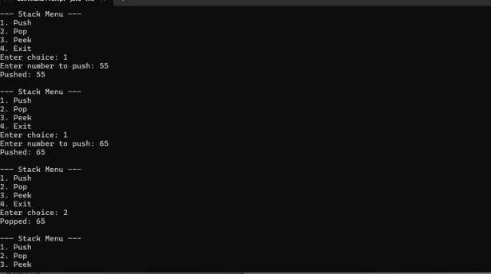

Ex.NO:5 StringManipulationUsingArrayListinJava

AIM:

TodevelopaJavaprogramthatdemonstratesdynamicstringoperationsusingtheArrayListclass.The program provides the following functionalities
- Append:Addastring totheendofthelist
- Insert:Insertastringataspecificindex
- Search:Checkifastringexistsinthelist
- Listallstringsstartingwithagivenletter

ALGORITHM:

PROGRAM:
importjava.util.ArrayList; import java.util.Scanner;
publicclassStringListOperations{
private ArrayList<String> strings=newArrayList<>(); private Scanner sc = new Scanner(System.in);

//Appendastringattheend public void append() {
System.out.print("Enterstringtoappend:"); String str = sc.nextLine();
strings.add(str);System.out.println("Appendedsuccessfully.");
}

//Insertstringatspecificindex public void insert() {
System.out.print("Enter index:"); int index = sc.nextInt(); sc.nextLine();//consumenewline
System.out.print("Enterstringtoinsert:"); String str = sc.nextLine();

if(index>=0&&index<=strings.size()){ strings.add(index, str);
System.out.println("Insertedsuccessfullyatindex"+index);
}else{
System.out.println("Invalidindex!");
}
}

// Search for a string publicvoidsearch(){
System.out.print("Enterstringtosearch:");
StringsearchStr=sc.nextLine();
if(strings.contains(searchStr)){
System.out.println("Stringfoundatindex:"+strings.indexOf(searchStr));
}else{
System.out.println("Stringnotfound.");
}
}

//Liststringsstartingwithagivencharacter public void listStartingWith() {
System.out.print("Enterstartingletter:");
charletter=sc.next().charAt(0);
booleanfound=false;
System.out.println("Stringsstartingwith'"+letter+"':");

for(Strings:strings){
if (s.toLowerCase().startsWith(String.valueOf(letter).toLowerCase())){ System.out.println(s);
found=true;
}
}
if(!found){
System.out.println("Nostringsfoundstartingwith'"+letter+"'");
}
}

// Display all strings publicvoiddisplayAll(){
if (strings.isEmpty()) { System.out.println("Listisempty.");
}else{
System.out.println("Current stringsinlist:"); for (int i = 0; i < strings.size(); i++) {
System.out.println(i+":"+strings.get(i));
}
}
}
//Menu
publicvoidmenu(){ int choice;
do{
System.out.println("\n--- StringOperations Menu ---"); System.out.println("1. Append"); System.out.println("2. Insert at Index"); System.out.println("3. Search");
System.out.println("4. List byStarting Letter"); System.out.println("5. Display All"); System.out.println("6. Exit"); System.out.print("Enter choice: ");
choice = sc.nextInt(); sc.nextLine();//consumenewline
switch(choice){
case1:append();break; case 2: insert(); break; case 3: search(); break;
case4:listStartingWith(); break; case 5: displayAll(); break;
case6:System.out.println("Exiting...");break;
default:System.out.println("Invalidchoice.Tryagain.");
}
}while(choice!=6);

}
//Main method
public static void main(String[] args) { StringListOperations ops=newStringListOperations(); ops.menu();
}
}

OUTPUT:
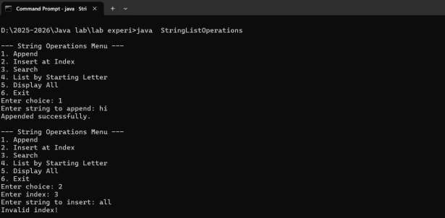

Ex.NO:6 AreaComputationofGeometricShapesUsingAbstractClassesinJava

AIM:
TodesignaJavaapplicationthatdemonstratestheuseofabstractclassesandinheritance by:

- CreatinganabstractclassShapewithtwointegermembersandanabstractmethod
printArea().
- Extendingtheabstractclassinthreederivedclasses: Rectangle,Triangle,andCircle.
- ImplementingtheprintArea()methodineachsubclasstocalculateanddisplaythearea specific to that shape.

ALGORITHM:

PROGRAM:
import java.util.Scanner;
// Abstract base class abstractclassShape{
inta,b;//Thesewillrepresentdimensions
abstractvoidprintArea();
}
//Rectanglesubclass
class Rectangle extends Shape { Rectangle(intlength,intbreadth){
a=length;
b=breadth;
}
@Override
voidprintArea(){ int area=a*b;
System.out.println("AreaofRectangle="+area);
}
}
//Trianglesubclass
class Triangle extends Shape { Triangle(intbase,intheight){
a=base;
b=height;
}
@Override
voidprintArea(){
double area = 0.5 * a * b; System.out.println("AreaofTriangle="+area);
}
}
//Circlesubclass
classCircleextendsShape{ Circle(int radius) {
a=radius;
}
@Override
voidprintArea(){
double area = Math.PI * a * a; System.out.println("AreaofCircle="+area);
}
}

//Mainclass
publicclassShapeDemo{
public static void main(String[] args) { Scannersc=newScanner(System.in);
//Rectangle
System.out.print("Enterlengthandbreadthofrectangle:"); int length = sc.nextInt();
intbreadth=sc.nextInt();
Shaperect=newRectangle(length,breadth); rect.printArea();
//Triangle
System.out.print("Enterbaseandheightoftriangle:"); int base = sc.nextInt();
intheight =sc.nextInt();
Shapetri=newTriangle(base,height); tri.printArea();
//Circle
System.out.print("Enter radiusofcircle: "); int radius = sc.nextInt();
Shapecirc=newCircle(radius);
circ.printArea();
sc.close();
}
}

OUTPUT:

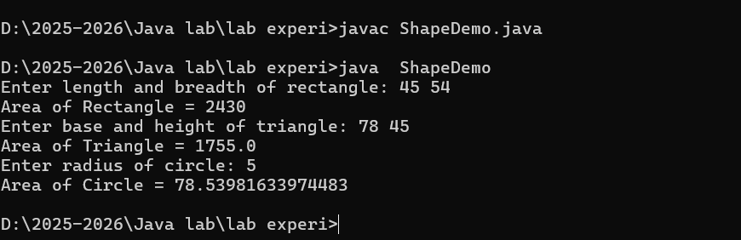

Ex.NO:7 User DefinedExceptionHandling.

AIM:

TodevelopaJavaapplicationthat demonstratesuser-definedexceptionhandlingby:

- CreatingacustomexceptionclassInvalidAgeException.
- Writinga methodthatchecksifauseriseligibletovotebasedonageinput.
- Throwingandhandlingthecustomexceptionwhentheuser’sageislessthan18.

ALGORITHM:

PROGRAM:
import java.util.Scanner;
//Customexceptionclass
class InvalidAgeException extends Exception { publicInvalidAgeException(String message) {
super(message);
}
}
//Mainclass
publicclassCustomExceptionDemo{
//Methodtocheckage
publicstaticvoidcheckEligibility(intage)throwsInvalidAgeException{
if(age<18){
thrownewInvalidAgeException("Agemustbe18oroldertovote.");
}else{
System.out.println("Youareeligibletovote!");
}
}

public static void main(String[] args) { Scannersc=newScanner(System.in);

System.out.print("Enteryourage:");
intuserAge=sc.nextInt();
try{
checkEligibility(userAge);
} catch (InvalidAgeException e) { System.out.println("Exception caught: "+e.getMessage());
}
sc.close();
}
}

OUTPUT:
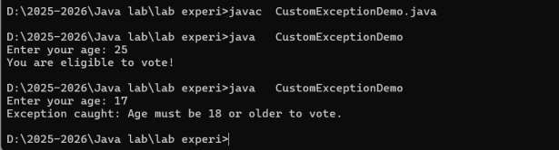

Ex.NO:8 FilePropertyInspectorUsingJavaI/O

AIM:

TodevelopaJavaprogramthat readsafilenamefromtheuseranddisplaysimportantinformationabout the file, including:
- Whetherthefileexists
- Whetheritisreadableandwritable
- Thetypeoffile(fileordirectory)
- Thelengthofthefileinbytes

ALGORITHM

PROGRAM:
import java.io.File; importjava.util.Scanner;
publicclassFileInfoChecker{
public static void main(String[] args) { Scannersc=newScanner(System.in);
// Read file name from user System.out.print("Enterthefilepath:"); String filePath = sc.nextLine();
//CreateFileobject
Filefile=newFile(filePath);

//Checkiffileexists if (file.exists()) {
System.out.println("\n---FileInformation---");

System.out.println("Name System.out.println("Path
: "+file.getName());
:" +file.getAbsolutePath());

System.out.println("Readable:"+file.canRead()); System.out.println("Writable:"+file.canWrite());

System.out.println("Type
System.out.println("Size
}else{
:"+(file.isFile()?"File":"Directory"));
:"+file.length()+"bytes");

System.out.println("Filedoesnotexist.");
}
sc.close();
}
}

OUTPUT:
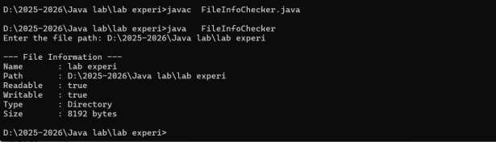

Ex. NO:9 ConcurrentProcessingofRandomNumbersUsingMultithreadinginJava AIM:
Todesignandimplement aJavaapplicationthatdemonstratestheconceptofmultithreadingandinter-
threadcommunicationby:
- Creatingathreadtogeneraterandomintegerseverysecond.
- Creatingseparatethreadsto:
- Computeanddisplaythesquareofevennumbers.
- Computeand displaythecubeofodd numbers.

ALGORITHM:

PROGRAM:
//Thread1:RandomNumber Generator
classRandomNumberGeneratorextendsThread{ public void run() {
Randomrand=newRandom();
for(inti=0;i<10; i++){
intnum=rand.nextInt(100);//Generaterandomnumber(0–99) System.out.println("\nGenerated Number: " + num);
if(num%2 ==0){
// If even, start Square thread newSquareThread(num).start();
}else{
// If odd, start Cube thread newCubeThread(num).start();
}
try{
Thread.sleep(1000);//Wait1secondbeforenextnumber
} catch (InterruptedException e) { System.out.println("Threadinterrupted.");
}
}
}
}

// Thread 2: Squareofevennumbers classSquareThreadextendsThread{
intnumber;

SquareThread(intnum){ this.number = num;
}
publicvoidrun(){
int square=number*number;
System.out.println("Square of"+number+"="+square);
}
}
// Thread 3: Cube of odd numbers classCubeThreadextendsThread{
intnumber;

CubeThread(intnum){ .number = num;
}
publicvoidrun(){
intcube=number*number*number;

System.out.println("Cubeof"+number+"="+cube);
}
}
//Mainclass
public class MultiThreadExample { publicstaticvoidmain(String[]args){
RandomNumberGenerator rng=newRandomNumberGenerator(); rng.start();
}
}

OUTPUT:
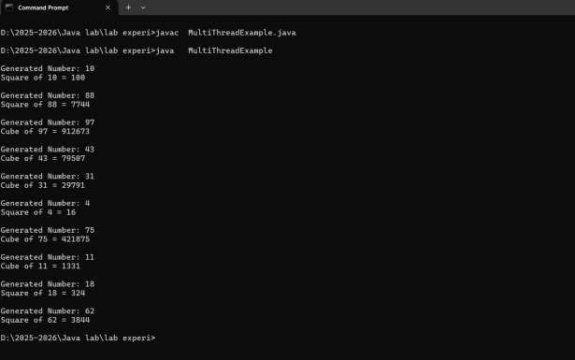

Ex.NO:12 Bank Account using Generics & Exception Handling in Java

AIM:
To implement a Bank Account class using Java Generics for balance type and demonstrate exception handling for invalid transactions.

ALGORITHM:

• Define a generic class BankAccount<T extends Number>.
• Store account number, name, and balance.
• Create methods:
deposit(T amount)
withdraw(T amount) (throw exception if insufficient balance or invalid amount)
• Handle exceptions using try-catch.
• Test the class in main().

PROGRAM:
// BankAccount.java
class InsufficientFundsException extends Exception {
public InsufficientFundsException(String msg) {
super(msg);
}
}

class BankAccount<T extends Number> {
private String name;
private String accNo;
private double balance;

public BankAccount(String name, String accNo, T balance) {
this.name = name;
this.accNo = accNo;
this.balance = balance.doubleValue();
}

public void deposit(T amount) {
balance += amount.doubleValue();
System.out.println("Deposited: " + amount);
}

public void withdraw(T amount) throws InsufficientFundsException {
double val = amount.doubleValue();
if (val <= 0)
throw new IllegalArgumentException("Amount must be positive");
if (val > balance)
throw new InsufficientFundsException("Insufficient balance");
balance -= val;
System.out.println("Withdrawn: " + val);
}

public void display() {
System.out.println("Account: " + accNo + " | Name: " + name + " | Balance: " + balance);
}
}

public class Main {
public static void main(String[] args) {
try {
BankAccount<Integer> acc = new BankAccount<>("Alice", "A123", 1000);
acc.deposit(500);
acc.withdraw(200);
acc.display();
acc.withdraw(2000); // will throw exception
} catch (InsufficientFundsException | IllegalArgumentException e) {
System.out.println("Error: " + e.getMessage());
}
}
}

OUTPUT:

